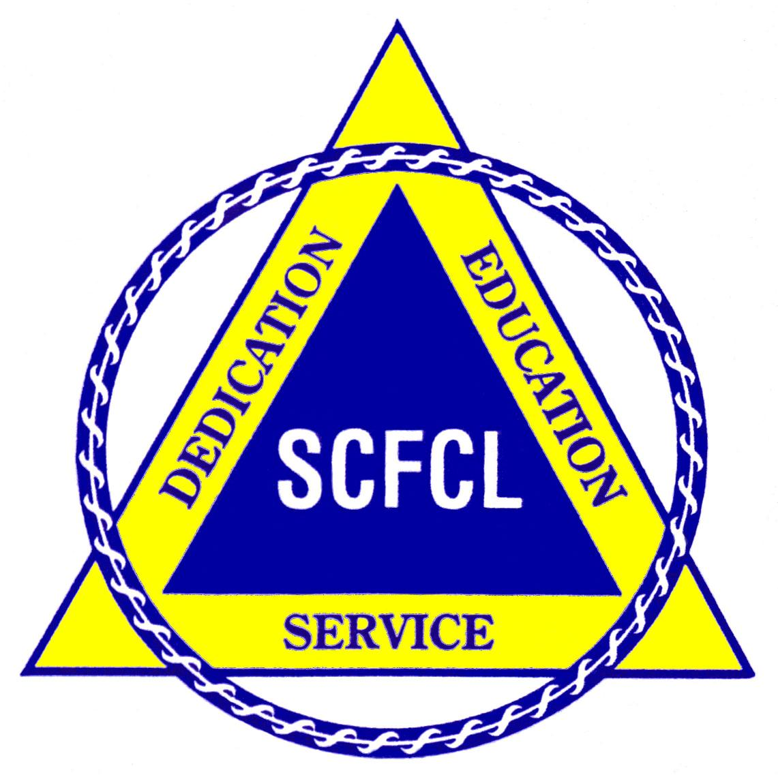
South Carolina
Family And Community Leaders

2016 Annual Meeting Registration Form
96th SCFCL Annual Meeting

"Sharing Your SCFCL Story"
October 22, 2016
state farmers market in Phillips Market Center
117 Ballard Ct.
W. Columbia, South Carolina 29172

Please keep a copy for your records, AND please fill out a separate form for each person attending. Please include a self-addressed, stamped envelope or an email address if you wish to receive registration confirmation.

Please print

Name____________________________________________Phone_______________

Address__________________________________________County______________

City_________________________State_____Zip__________

Email________________________________________________________________

(Check all that apply)
Voting Delegate_____Advisor____Board Member___State Office Held ________

Member _______New Member______First Time at Conference______
Guest or Non-Member _______

Dietary Restrictions_______________________________________________

Registration Deadline OCTOBER 3, 2016. A $10 late fee will be charged if registration is received after October 3.

Conference Registration Fee (including refreshments, lunch and workshop)
Members: $35 Non Members $40

TOTAL AMOUNT SUBMITTED___________ FEES ARE TRANSFERABLE NOT REFUNDABLE

MAKE CHECKS PAYABLE TO SCFCL AND SEND WITH FORMS TO HEATHER KENNEDY, 2163 POINSETTIA AVE., SUMMERVILLE, SC 29486

Contact nformation:
HEATHER KENNEDY: (843) 607-2655; BETTY OSGOOD (843) 761-2916 OR (843) 437-0762

